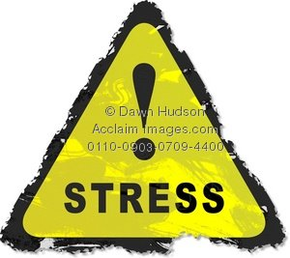
Stress Terms & Key Facts

1. Define Stress:

2. Define Adrenaline:

3. Define Fatigue (Physical and Emotional):

4. Define Stressor:

5. Define Coping Skills:

List some healthy and unhealthy coping skills below:

Healthy Coping Skills Unhealthy Coping Skills

6. Define Eustress and provide 2 examples of it in your life:

7. Define Distress and provide 2 examples of it in your life:

8. What is the purpose of your body’s Fight or Flight response?

9. What are the 6 ways the body reacts during Fight or Flight?

1. 4.

2. 5.

3. 6.

10. What’s the difference between long-term stress and short-term stress?

If you have a lot of stress in your life for a long period of time, what are 2 ways stress could affect each side of the wellness wheel (8 ways in total)

- Physical:

- Mental

- Emotional:

- Social:

What are three key things that you can take away from the TED Talk by Dr. McGonigal?

1.

2.

3.

At the end of the talk, she says “Chasing meaning is better for your health than trying to avoid discomfort.” What do you think that means? Try your best to define it in your own words and give some examples.

